Career Progression and Promotion Gap Analysis for Retention Optimization
at Palo Alto Networks
Unified Mentor
Research Report — Explanation and Findings

Abstract
Traditional attrition models identify which employees are likely to leave, but rarely explain the structural career issues that push them toward that decision. This report documents the end-to-end analysis of career trajectory intelligence at Palo Alto Networks: exploratory data analysis (EDA) on the employee HR dataset, engineering of four career-progression ratio features, categorical encoding and outlier treatment, unsupervised career-path clustering (K-Means, validated with Hierarchical clustering), a combined Promotion Gap Risk score, and identification of Retention Opportunity employees — those who are not yet disengaged but show measurable career stagnation. The result is a fully processed, model-ready dataset and an interactive Streamlit dashboard that together let HR stakeholders move from reactive retention to proactive, career-centric workforce management.

1. Exploratory Data Analysis (EDA) on Career and Attrition Patterns
The dataset contains 1,470 employee records across 31 raw fields covering demographics, compensation, satisfaction survey scores, and career-tenure variables. Before any modelling, we established baselines: there were no missing values and no duplicate rows, giving us a clean starting point. Of the 1,470 employees, 237 (16.1%) have historically left the organisation (Attrition = 1) against 1,233 (83.9%) who stayed — a class imbalance that is typical of HR attrition data and informs how the risk and retention logic later in the pipeline is designed.
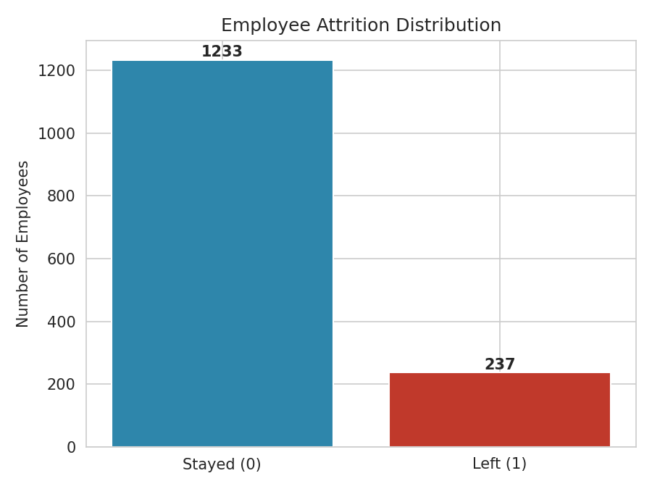
Figure 1. Employee Attrition Distribution

1.1 Correlation Analysis
A correlation heatmap was generated across all numerical fields to expose linear relationships with Attrition and to check for multicollinearity between candidate features before engineering ratios from them. TotalWorkingYears, JobLevel, YearsInCurrentRole, MonthlyIncome, Age and YearsWithCurrManager emerged as the strongest numerical correlates of attrition, though all individual correlations remain modest (|r| < 0.18) — consistent with the report's core premise that attrition is driven by structural, multi-factor career patterns rather than any single variable.
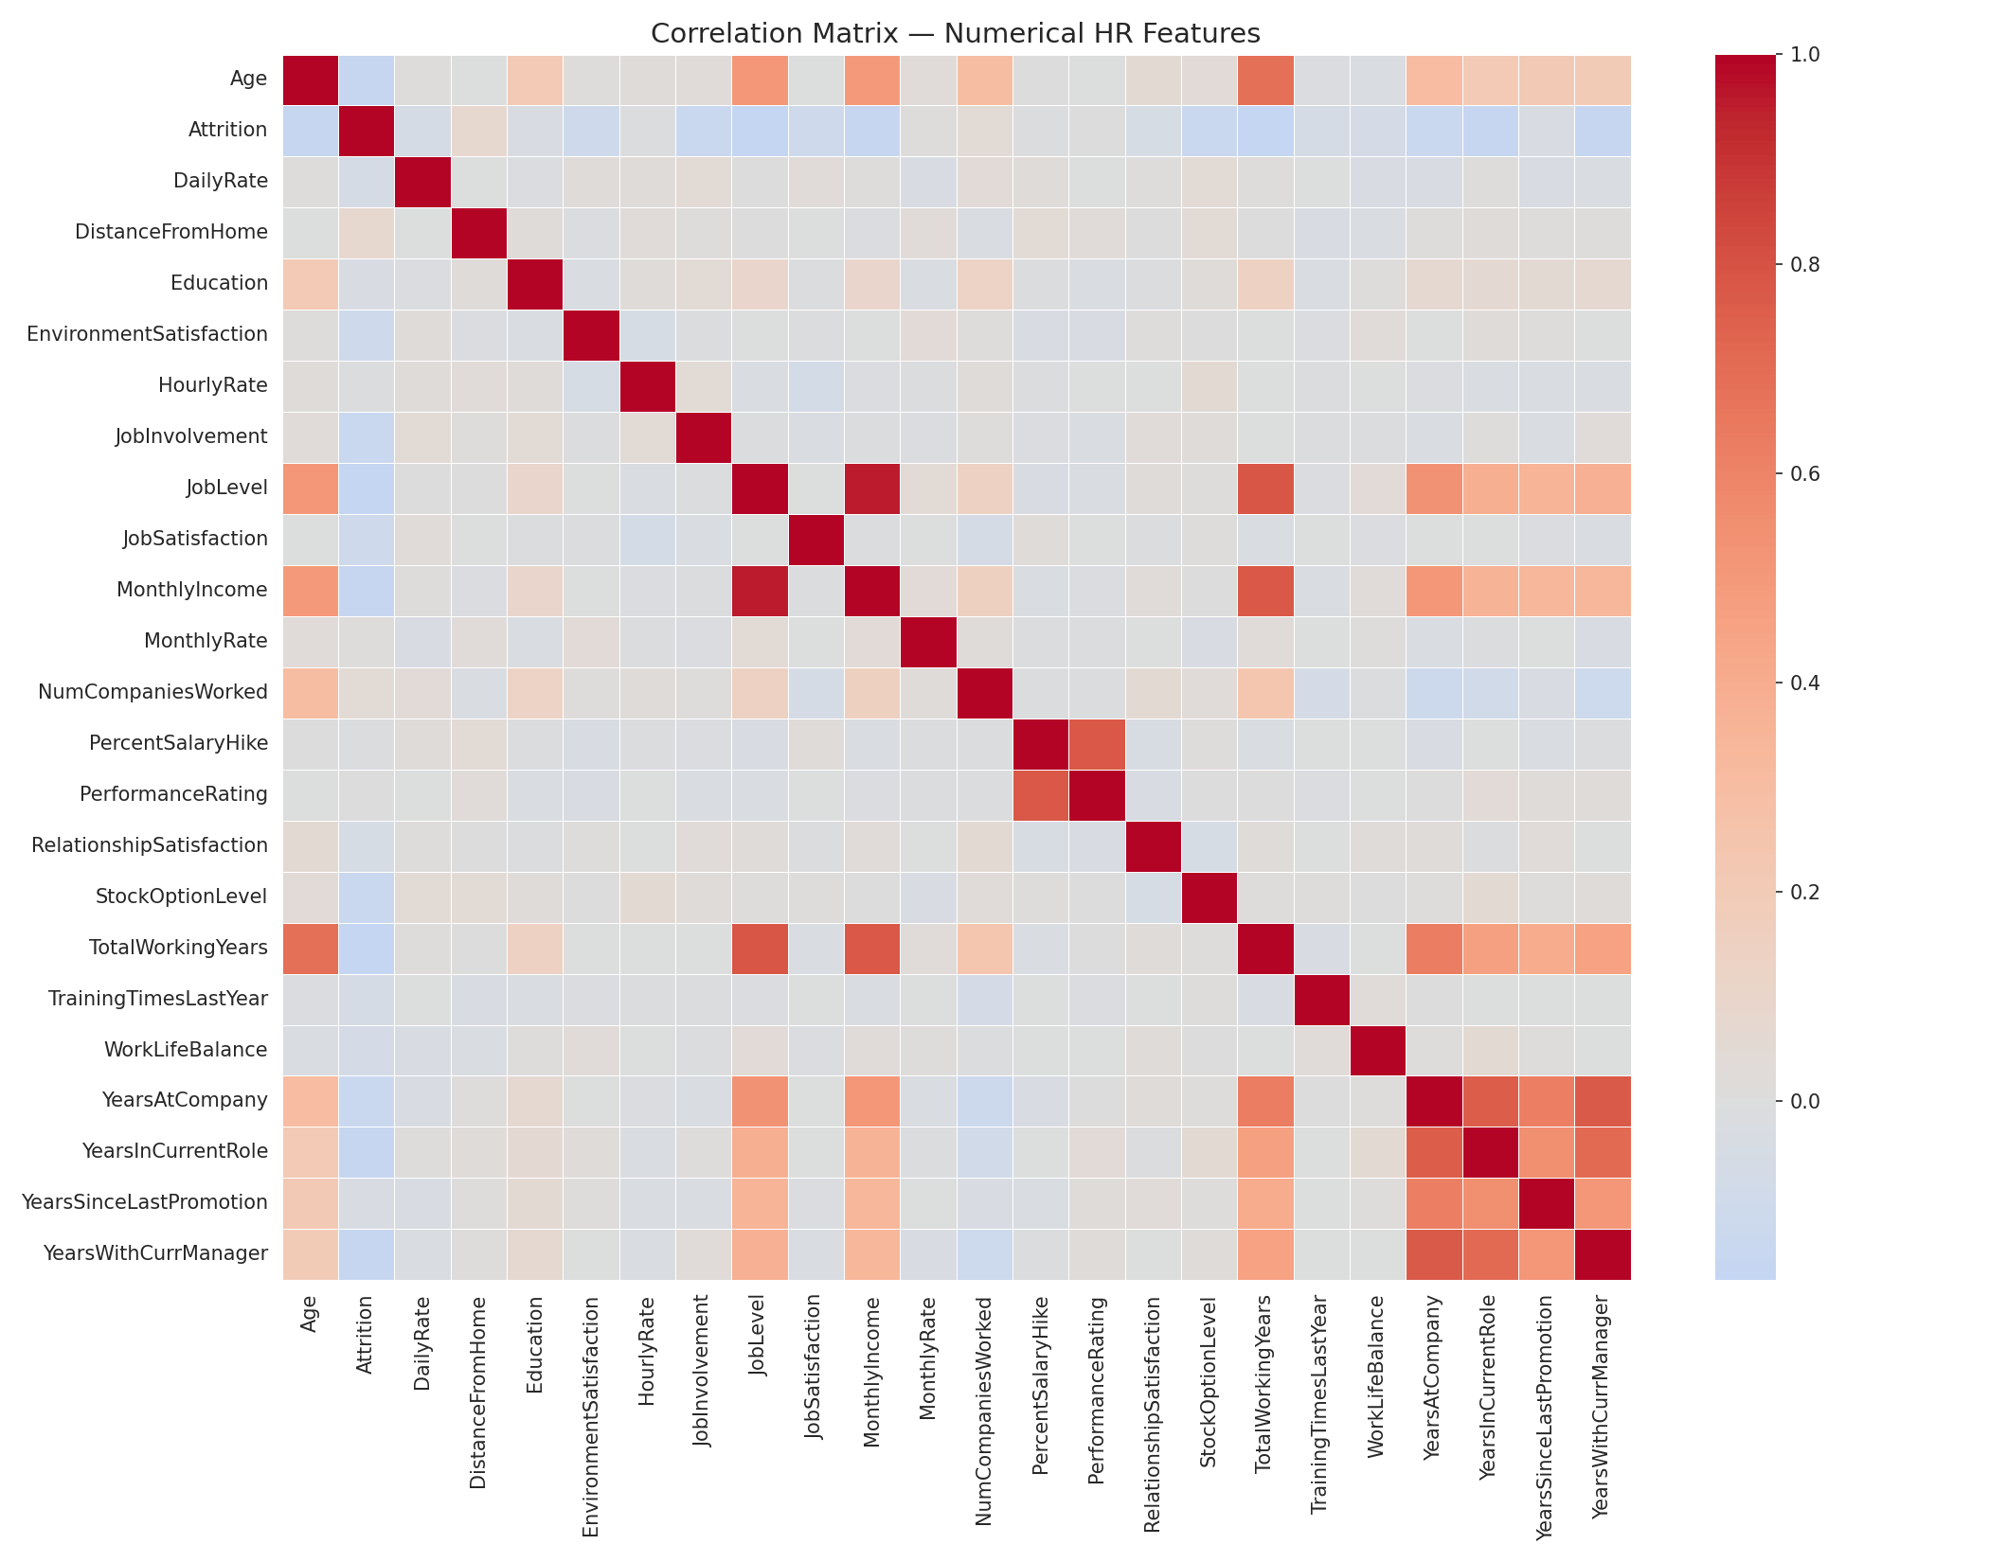
Figure 2. Correlation Matrix — Numerical HR Features

1.2 Outlier Screening on Career Tenure Variables
The five tenure-related variables that anchor the engineered ratios — YearsAtCompany, YearsInCurrentRole, YearsSinceLastPromotion, YearsWithCurrManager and TotalWorkingYears — were screened for outliers using the IQR method. Boxplots (Figure 3) confirm a right-skewed distribution typical of tenure data, with a small number of long-serving employees (some with 30+ years of total experience) sitting well beyond the interquartile range.
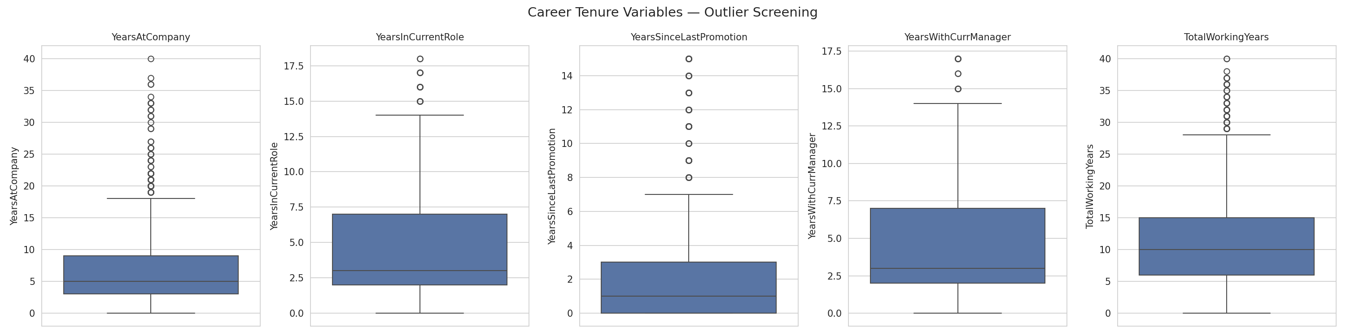
Figure 3. Career Tenure Variables — Outlier Screening
Insight Discovered: Distance-based clustering algorithms such as K-Means are sensitive to extreme values. Left untreated, the handful of very long-tenured employees would disproportionately pull cluster centroids and distort the segmentation for the remaining 98%+ of the workforce. This directly motivates the outlier-removal step performed in Section 2.3.

1.3 Attrition by Department and Job Role
Attrition rate was aggregated by Department and by Job Role to see whether departure risk concentrates in specific parts of the organisation.
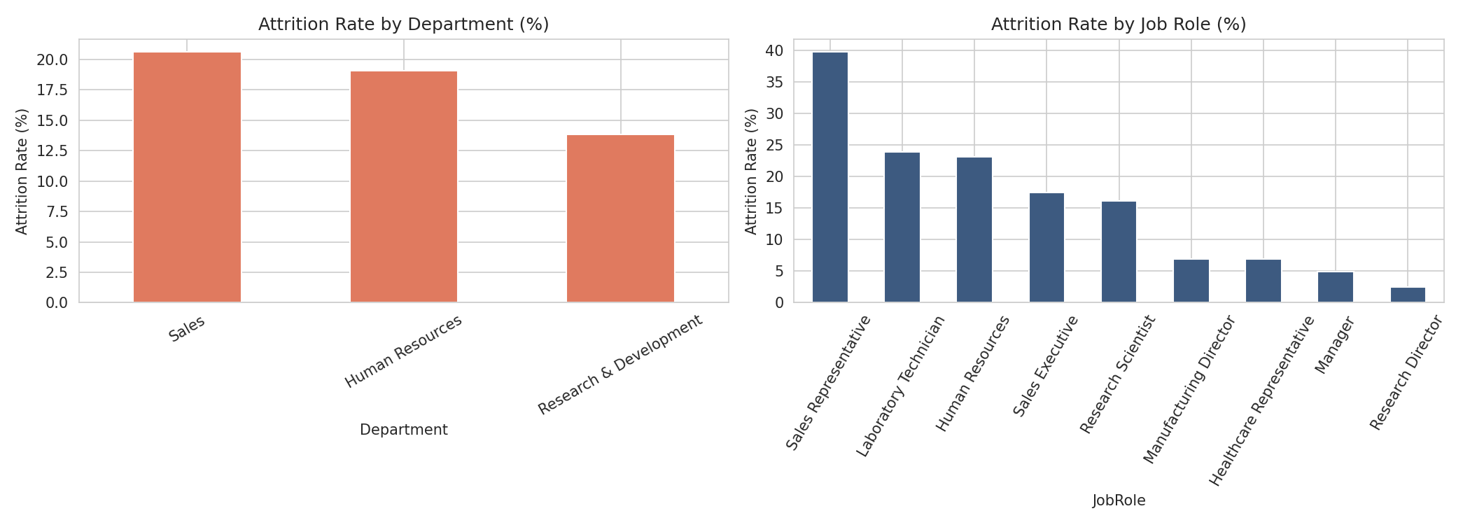
Figure 4. Attrition Rate by Department and Job Role
Insight Discovered: Sales and certain individual-contributor roles (Sales Representative, Laboratory Technician, Human Resources) show visibly higher attrition rates than senior/managerial roles. This role-level pattern is revisited in Section 4 through the lens of promotion-gap risk rather than raw attrition alone.

2. Feature Engineering and Data Preprocessing
Four derived, tenure-normalised metrics were engineered so that career progression could be compared fairly across employees with very different lengths of service:
- Promotion Gap Ratio = YearsSinceLastPromotion / YearsAtCompany
- Role Stagnation Index = YearsInCurrentRole / YearsAtCompany
- Training Intensity Score = TrainingTimesLastYear / YearsAtCompany
- Manager Stability Indicator = YearsWithCurrManager / YearsAtCompany
Employees with YearsAtCompany = 0 are assigned a ratio of 0 for all four metrics to avoid division-by-zero errors, since a brand-new joiner cannot yet show a promotion gap or stagnation signal.
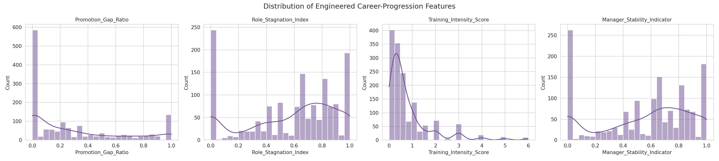
Figure 5. Distribution of Engineered Career-Progression Features

2.1 Categorical Encoding
Text-based categorical fields — BusinessTravel, Department, EducationField, Gender, JobRole, MaritalStatus and OverTime — were label-encoded into parallel *_Code numerical columns. The original text columns were retained so the Streamlit dashboard can continue to filter and display human-readable labels, while the numeric codes are available for any downstream statistical or machine-learning use that requires purely numerical input.

2.2 Outlier Removal (Late-Career Edge Cases)
Using an IQR rule (k = 3, i.e. only the most extreme, "far" outliers) applied to YearsAtCompany and TotalWorkingYears, 19 late-career edge-case records were removed from the working dataset of 1,470, leaving 1,451 employees for clustering and risk scoring. This threshold was chosen deliberately conservative (k = 3 rather than the standard k = 1.5) so that only genuinely extreme records are dropped, preserving the great majority of legitimately senior staff for analysis.

3. Career Path Clustering (Unsupervised Learning)
All six clustering inputs — Promotion_Gap_Ratio, Role_Stagnation_Index, Training_Intensity_Score, Manager_Stability_Indicator, YearsAtCompany and TotalWorkingYears — were standardised with Scikit-Learn's StandardScaler (Z-score normalisation) so that no single feature dominates the distance calculation purely because of its numeric scale.

3.1 K-Means Clustering (Primary Method)
K-Means (k = 4, random_state = 42, n_init = 10) was applied as the primary segmentation method, producing a silhouette score of 0.306 — a reasonable, well-separated structure for HR survey-style data with mixed ratio and count features.

3.2 Hierarchical Clustering (Validation)
To validate that the four segments are not an artefact of K-Means' specific initialisation, Agglomerative (Ward-linkage) Hierarchical Clustering was independently run on the same standardised features with the same k = 4. Its silhouette score (0.279) is close to the K-Means result, and the Adjusted Rand Index between the two algorithms' cluster assignments is 0.725 — a strong level of agreement that confirms the four-segment structure is a genuine pattern in the data rather than a modelling artefact.
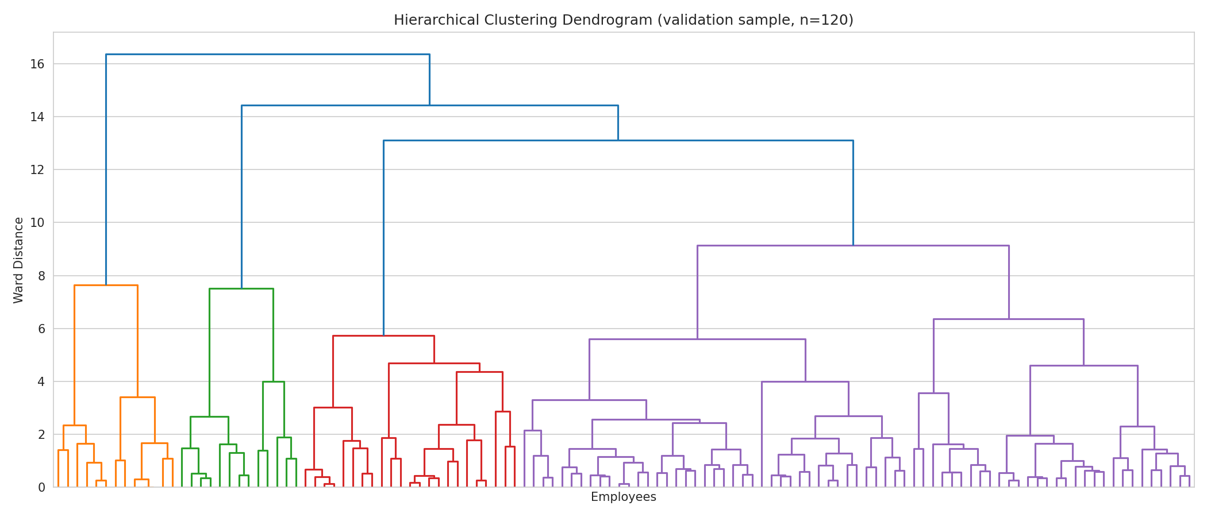
Figure 6. Hierarchical Clustering Dendrogram (validation sample)

3.3 Cluster Interpretation and Labelling
Rather than hardcoding a fixed cluster-index-to-label mapping (which breaks if the data or random seed changes), clusters are labelled dynamically by ranking each cluster's mean Promotion_Gap_Ratio and TotalWorkingYears. The four resulting career segments are:
Career Segment | Employees | Avg. Promotion Gap Ratio | Avg. Tenure (yrs) | Profile
Promotion-Stalled / Stagnant Profiles | 279 | 0.85 | 9.4 | Highest promotion gap and role stagnation — primary intervention group
Long-term Contributors / Senior Staff | 240 | 0.33 | 22.2 | Longest-serving, moderate promotion gap consistent with senior roles
Steady Performers / Fast-Trackers | 721 | 0.12 | 9.0 | Largest segment; low promotion gap, healthy training intensity
Early-Career Explorers / New Joiners | 211 | 0.07 | 7.2 | Shortest company tenure, lowest manager-continuity by definition

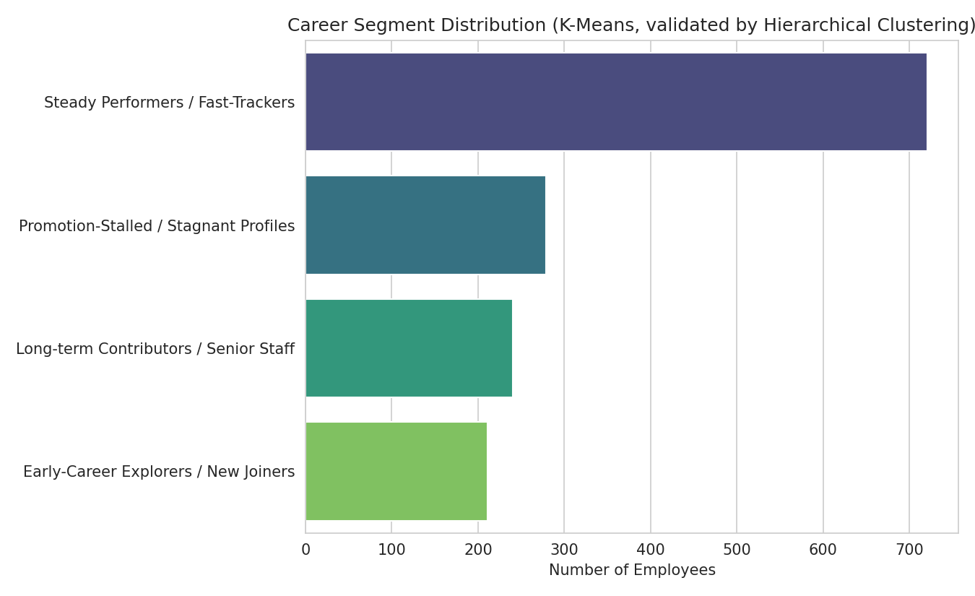
Figure 7. Career Segment Distribution

4. Promotion Gap Risk Scoring
Each employee is assigned a Low / Medium / High Promotion Gap Risk tier. The base tier comes from Promotion_Gap_Ratio thresholds (Low = 0, Medium = 0–0.35, High > 0.35); as required by the project brief, this is then combined with cluster membership — any employee sitting in the Promotion-Stalled cluster with a borderline Medium ratio is escalated to High, since cluster membership captures compounding stagnation signals (role stagnation, low training intensity, poor manager continuity) that a single ratio alone would miss.
Risk Tier | Employees | % of Workforce
Low | 579 | 39.9%
Medium | 427 | 29.4%
High | 445 | 30.7%

5. Key Performance Indicators
KPI | Description | Result
Career Cluster | Employee career trajectory type | 4 validated segments (Section 3.3)
Promotion Gap Score | Risk of stagnation | 30.7% of workforce at High risk
Retention Opportunity Index | Intervention priority | 366 High-Priority targets identified
Training Need Indicator | Development planning flag | 334 employees flagged "Needs Development Plan"
Manager Stability Impact | Leadership continuity insight | Low-continuity employees attrite at 17.7% vs. 14.5% for high-continuity

The Manager Stability Impact KPI (Figure 8) quantifies a specific structural risk called out in the project brief: weak managerial continuity. Employees whose Manager_Stability_Indicator sits below the workforce median show a meaningfully higher historical attrition rate than those with high manager continuity, supporting manager-continuity programs as a concrete retention lever.
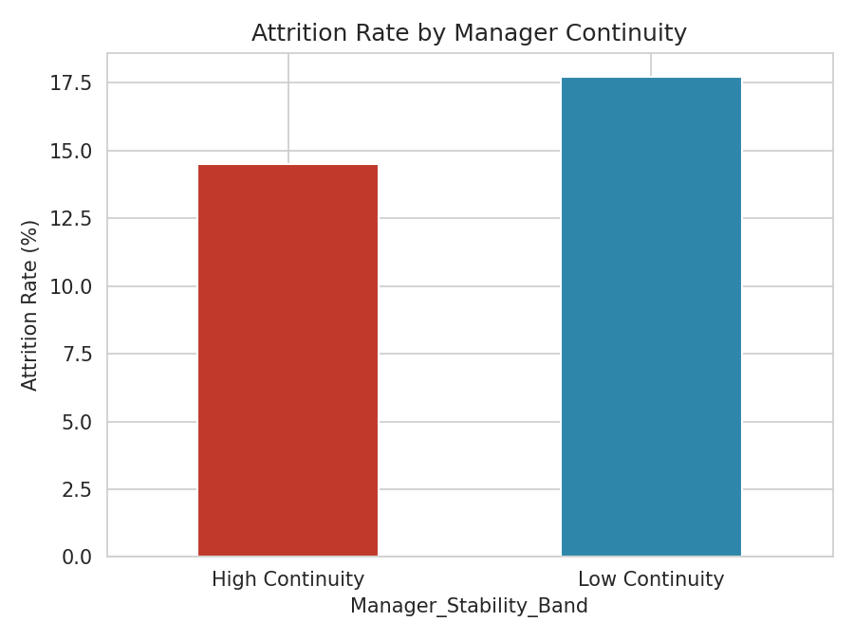
Figure 8. Attrition Rate by Manager Continuity

6. Retention Opportunity Identification
Retention Opportunity employees are defined as those who are not yet flagged as historical attrition risks (Attrition = 0) but who fall into the High Promotion Gap Risk tier — in other words, people showing the early structural warning signs of disengagement before they have actually left or shown other attrition indicators. 366 employees (25.2% of the retained workforce) meet this definition and form the core target list for HR intervention.
For each High-Priority employee, a rule-based Suggested Action is generated by combining their Training Need Indicator, Role Stagnation Index, Promotion Gap Ratio and Manager Stability Band, producing concrete next steps such as "Enroll in training / upskilling", "Consider role rotation", "Schedule promotion review", or "Review manager continuity" — directly satisfying the brief's requirement for suggested actions (training, rotation, promotion review) rather than a generic risk flag alone.

7. Streamlit Web Application
An interactive Streamlit dashboard (4_app.py) was built with five modules, directly mapping to the project brief's dashboard requirements:
- Career Path Clustering Dashboard — segment distribution, 3D stagnation/experience map, and a per-cluster explorer with pattern summaries.
- Promotion Gap Monitor — risk-tier distribution, role-level stagnation ranking, and a department → role → risk sunburst drill-down.
- Retention Opportunity Panel — high-priority target counts, a breakdown of suggested actions, and a what-if promotion-intervention simulator.
- Managerial Insight Dashboard — manager continuity vs. role stagnation, attrition by manager continuity, and team-level stagnation signals by department.
- Target Export — the full high-priority roster with a one-click CSV download.
All four required user capabilities are implemented in the sidebar: Department and Job Role filters, a Career Stage selector (tenure-band derived), a Promotion Gap threshold slider, and Career Cluster filtering that doubles as the cluster explorer.

8. Recommendations
- Prioritise the 366 High-Priority Retention Opportunity employees for structured career conversations within the current quarter.
- Target the Promotion-Stalled / Stagnant Profiles cluster (279 employees, 0.85 avg. promotion gap ratio) for a formal promotion-review cycle.
- Pair the 334 employees flagged by the Training Need Indicator with development plans, prioritising roles with the highest role-level stagnation identified in the Promotion Gap Monitor.
- Investigate manager-continuity practices in teams with high Low-Continuity concentration, given the observed uplift in attrition risk.
- Re-run the clustering pipeline quarterly as new HR data arrives, since the dynamic cluster-labelling logic will automatically re-adapt labels to the current data rather than relying on a fixed mapping.

9. Conclusion
This project moves beyond predicting who might leave to explaining why employees may eventually disengage, by quantifying promotion gaps, role stagnation, training intensity and manager continuity into a validated four-segment career-trajectory model. The K-Means segmentation is independently confirmed by Hierarchical clustering (Adjusted Rand Index = 0.725), the Promotion Gap Risk score combines both ratio-based and cluster-based signals, and the Retention Opportunity logic surfaces 366 employees with concrete, rule-based suggested actions. Packaged together with the Streamlit dashboard, the analysis gives Palo Alto Networks a repeatable, data-driven foundation for proactive, career-centric retention management — clearly distinct from traditional attrition-prediction models in its goal, methodology and business value.

